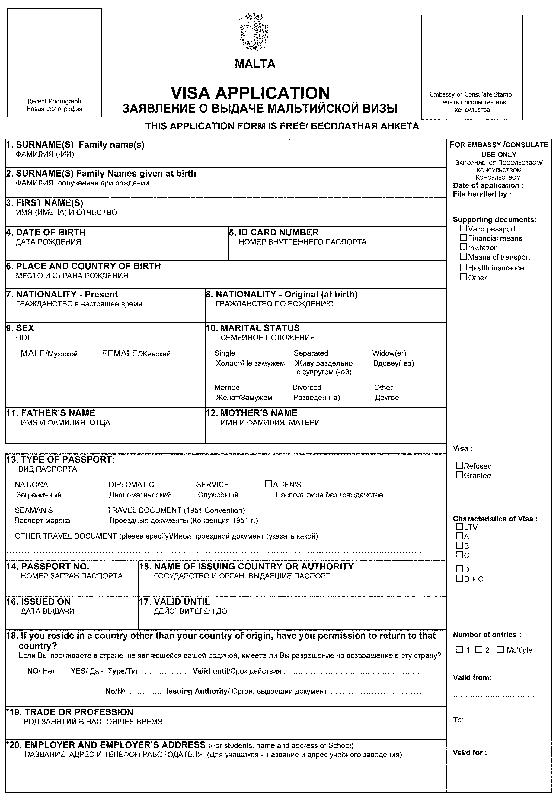
SOBOLEVSKAYA
NIKONOVA
OLGA ALEXANDROVNA
01/01/1975
45 05 123456
MOSCOW USSR
RUSSIA
USSR

ALEXANDER NIKONOV
MARINA NIKONOVA

51N1234567
MFA
24.04.2005
24.02.2010

BRAND MANAGER
COCA COLA CIS, MOSCOW, TVERSKAYA STR. 5
TEL. +7 499 956 56 56

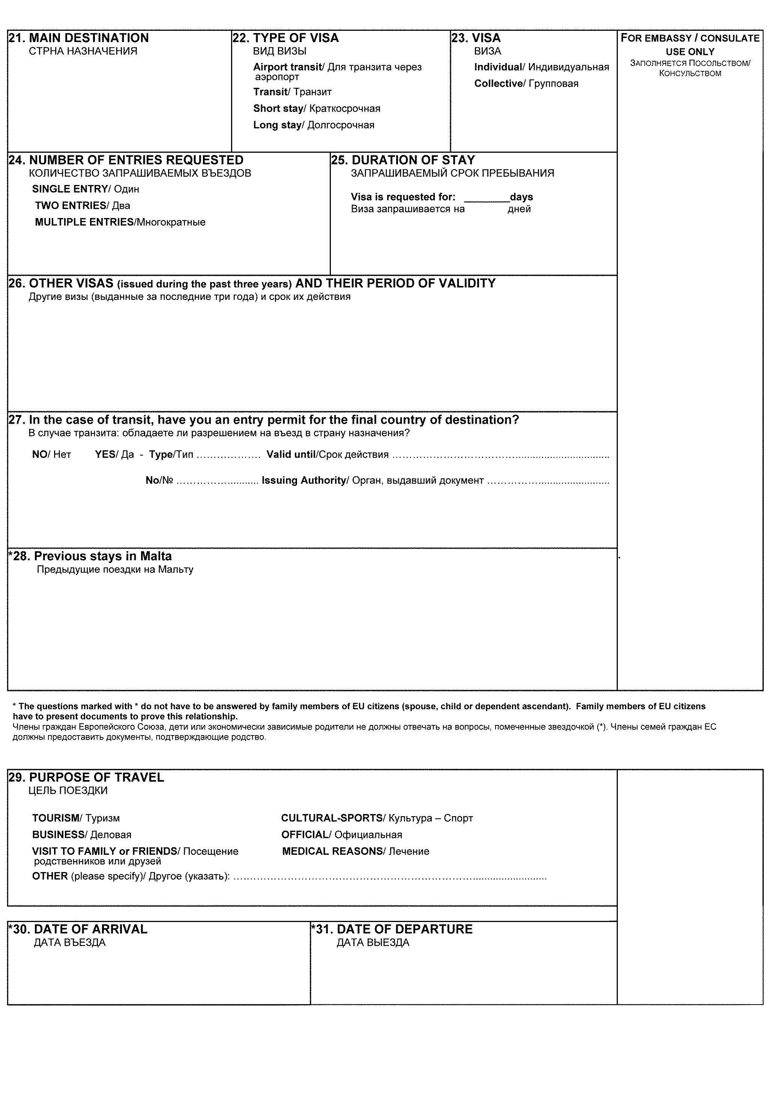
MALTA

15
USA 01.01.2007-01.01.2008, CYPRUS 15.08-30.08.2007, SWITZERLAND 02.01-12.01.2008, GERMANY 05.01.2007-05.01.2008

N/A

01.05.2008
10.05.2008

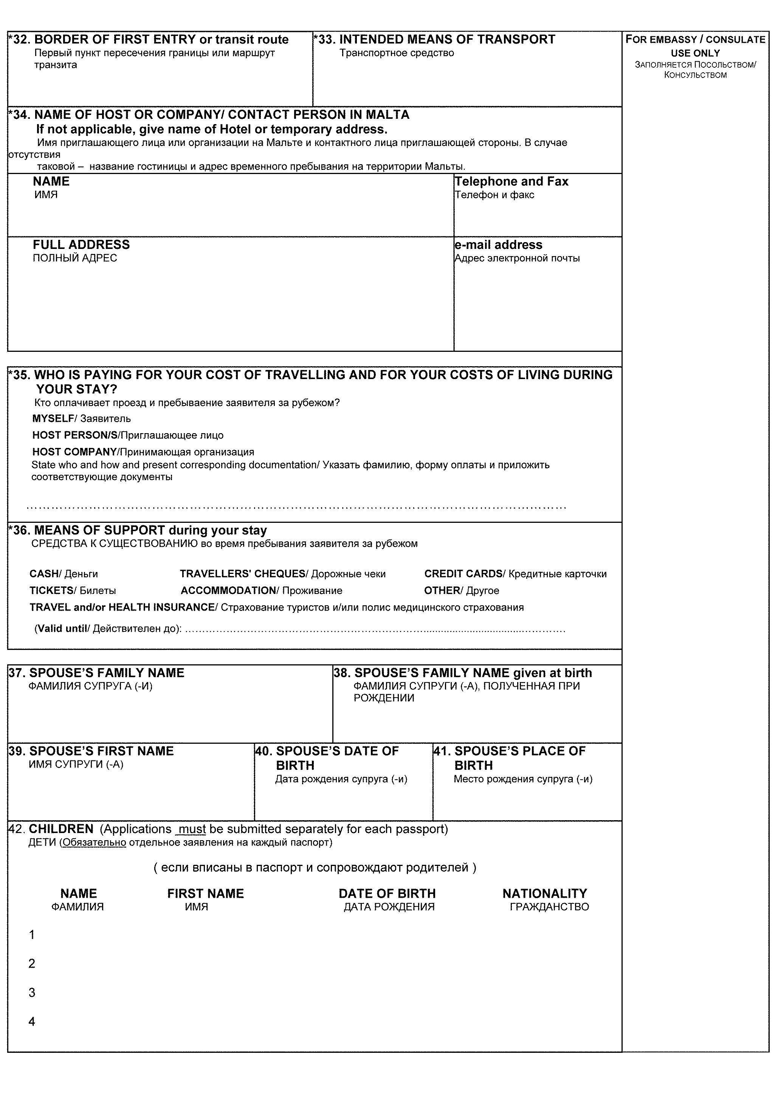
MALTA INTERNATIONAL AIRPORT
AVIA

10.05.2008
SOBOLEVSKIY

OLEG
03.07.1073
MOSCOW
Sobolevskiy
Igor
26.10.2005
RUSSIA

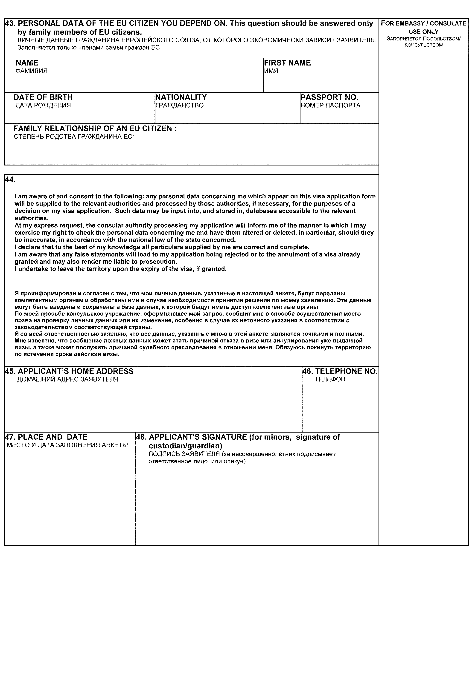
N/A
N/A
N/A
N/A
N/A
N/A
113126, MOSCOW SHABOLOVKA STR., 35 - 24
+7 499 1310101
MOSCOW, 05.03.2008

